16. **CREATE THE ARFF FILE FOR THE DIABETES DATABASE AND PERFORM SVM BASED CLASSIFICATION**

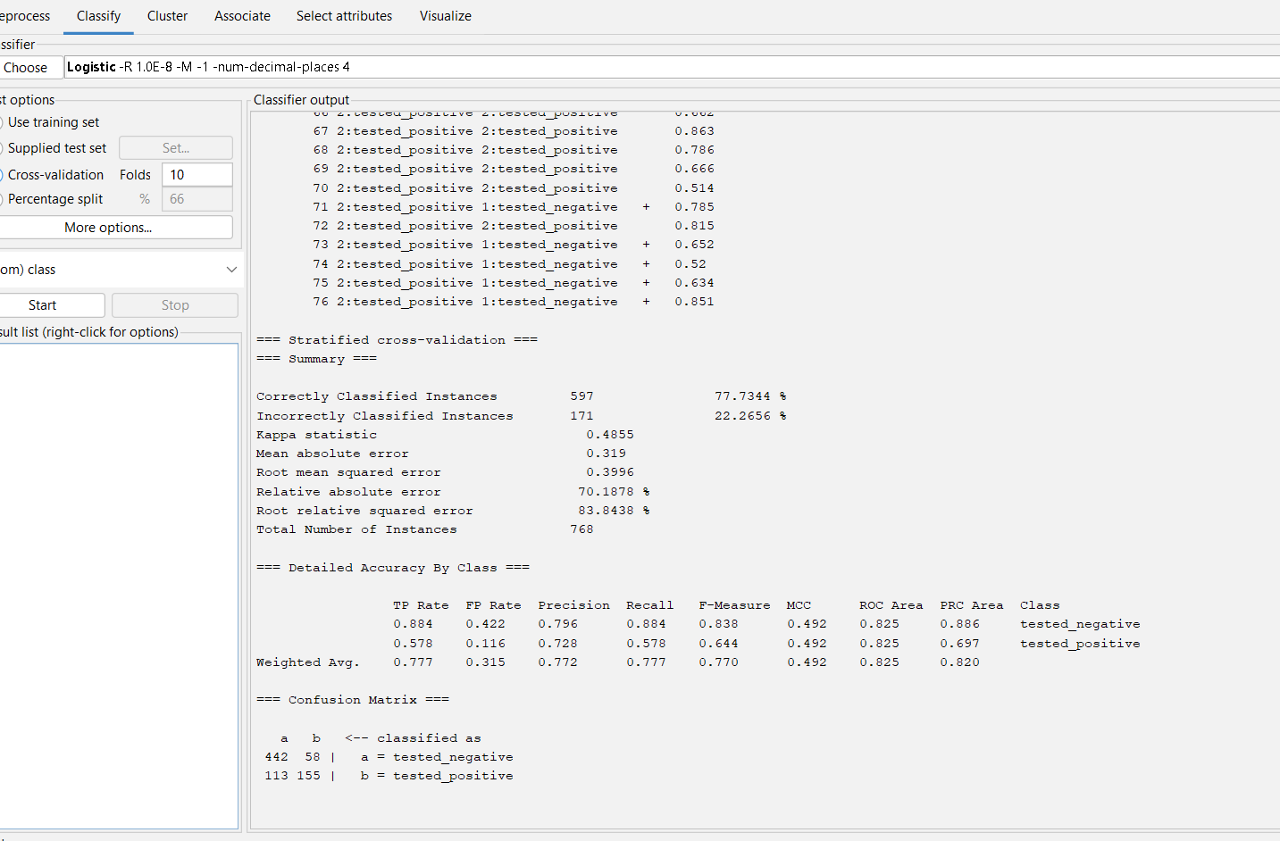

Output information of data diabetes with logistics.